Hi Support
Use of table from the pagebuilder addon list seems to have a problem
The default values can not be edit or replased by new values. If all Table Head Items and defalt row is deleted and replace by new values nothing is shown in the front end
Question Is this issue alredy reported and will this be soled in a hot fix soon
Please see below where I have added a table to a new page

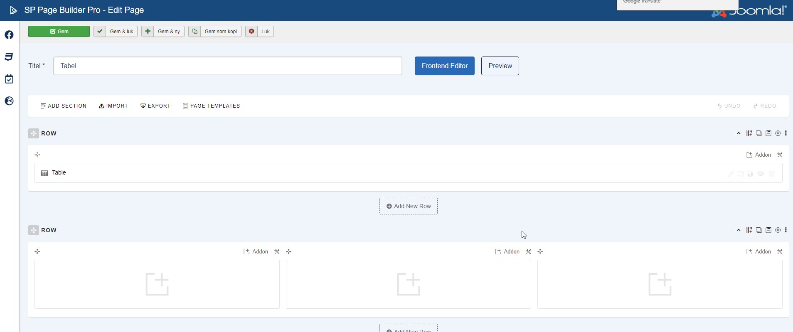

When editing the table you will see the below menu
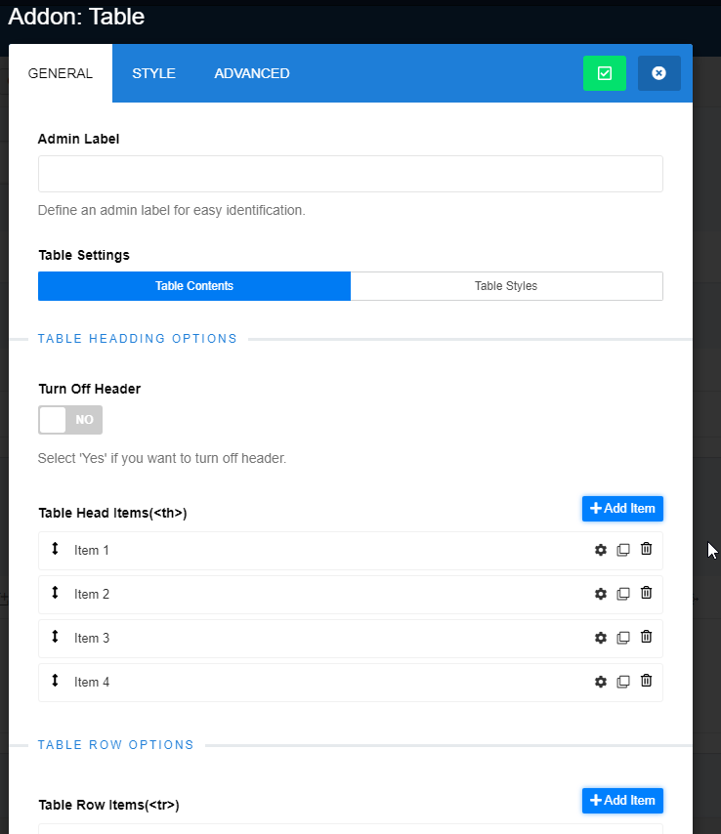

When I save the new table page and do a preview on the front end I see the below page
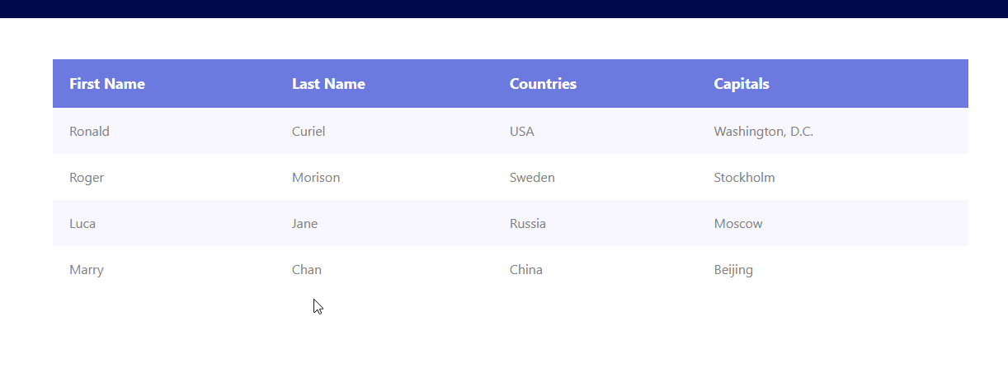

If I go back and edit the default values like below

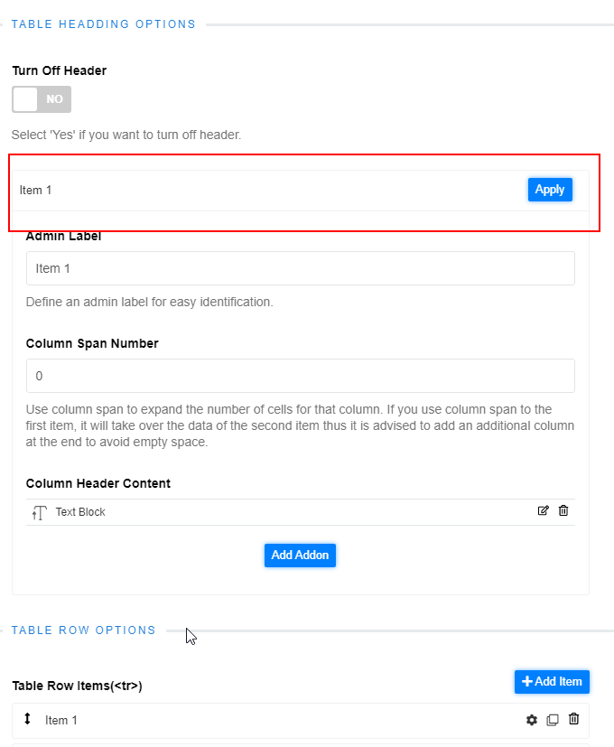

New values or added values is not will not be shown in the front end

I hope this explain the issues?

